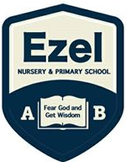 | EZEL NURSERY AND PRIMARY SCHOOL  Home Learning Program  www.ezelschool.com/homelearning.html
PRIMARY ONE

Week 1
MONDAY
 | Topics | Activities
Math | - counting  - number line addition  - which number is more | - Count numbers from 1 to 50  - Write numbers 1 to 50
English | - Language Practice | - Vocabulary: disease, mosquito , malaria  Activity:  - Find the meaning of the following words and write it in your exercise books.
Literacy | - Say out loud the letters, sounds and word | - Write the alphabet letters a – z.  - Write down the 5 vowel letters  - Say the sounds of the vowel letters.
Read the Story | My Little Goat by Bukheye Mulongo Christopher  Where are you going my little goat?  I am going to the market to buy a new coat.  "A coat for a goat?" asked the chicken.  "Can a goat have a coat?" asked the man.  Everyone will laugh at a goat with a coat!  But my little goat likes her new coat.  Goodbye goat!
TUESDAY
 | Topics | Activities
Math | - counting  - number line addition  - which number is more | Activity: Count the shape and write the number.  For example: = One , 1  - =  - =  - =  - =
English | Language practice | - Vocabulary: disease, mosquito, malaria  Activity:  - Write one sentence using each word.
Literacy | letters, sounds and words | - letters A, B , C , D , E, F  - Say the sound of each vowel letter  - Write 5 words for each vowel letter
Reading assignment | Read the My Little Goat story.
WEDNESDAY
 | Topics | Activities
Math | - counting  - number line addition  - which number is more | Activity: Draw circles to show addition:  1. 2+3= 3. 1+4= 5. 7+5=  2. 4+4= 4. 13+1=
English | Learn new words | Vocabulary: greeting, book, school, pupil  Activity: Find the meanings of the following words and write it in your exercise book.
Literacy | Practicing letter sounds | - letters G, H, I , J , K  - Say the sounds of letter G , H , I , J, K  - Say words that begin with letter G , H, I, , J, K
Reading assignment | Read the My Little Goat story.
THURSDAY
 | Topics | Activities
Math | - counting  - number line addition  - which number is more | Activity: Count on the number line:  7, 12, 15, 6, 8  Example of 3 on a number line.  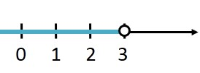
English | Language practice | Vocabulary: greeting, book, school, pupil.  Activity: Write one sentence using each of the vocabulary words.
Literacy | Sound ‘a’ syllables | Ba, ca, da, fa, ga, ha, ja, ka, la, ma, na, pa, ra  Activity:  Read and write down the syllables.
Reading | My Little Goat
FRIDAY
 | Topics | Activities
Math | Practice counting, shapes, numbers and patterns | Activity: Count on the number line:  20, 10, 5, 14, 11
English | Language practice | Vocabulary: greeting, book, school, pupil.  Activity: Write one sentence using each of the vocabulary words.
Literacy | Sound ‘a’ syllables | Ba, ca, da, fa, ga, ha, ja, ka, la, ma, na, pa, ra  Activity:  Read and write down the syllables.
Story reading | My Little Goat

Note: Dear parents/caregivers always make sure that
- You explain new words to your child.
- Recite new words as many times as you can
- Be kind and patient with your child, they cannot learn new things in one day.
- Provide your child with books, pencils, crayons and papers.
- Read the stories for the child and ask them questions to see if they understand.
- Where necessary, explain the story to the child.

ACTIVITIES
Activity 1 (Mathematics) : Answer the following
- 3 + 6 =  - 1+ 4 =  - 4 + 4 =  - 2 + 2 =  - 4+ 4 = | - 9 + 3 =  - 9 + 6 =  - 7 – 3 =  - 5 – 3 =  - 7 – 6 =

Activity 2 (English) : Name and Write down 5 animals that you know.
Activity 3 (English) : Read the story “Where is my book?” Answer the questions below
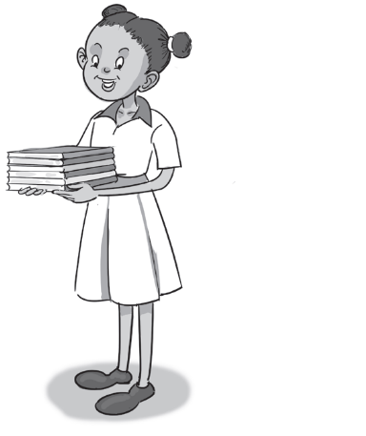 | Where is my book?  ‘Do you see my book?’ asks Jane.  ‘I do not see a book,’ says Bill.  ‘I need it,’ Jane says. ‘I need my book back.’  Bill is sad. ‘I will help you look,’ he says.  Bill and Jane look for the book.  Bill is happy. ‘Look! Here are some books!’  Jane is happy. ‘Thank you, Bill!’ she says.  1. What does Jane need?....................................................  2. How does Bill help?.........................................................  3. What is the problem?......................................................  4. Did you like the story? Why or why not?...................................
Activity 4 (Mathematics) : Answer the following
- 2 + 5 =  - 2+ 5 =  - 2 + 7 =  - 4 + 3 =  - 2+ 6 = | - 8 + 8 =  - 9 + 8 =  - 7 – 2 =  - 9 – 3 =  - 4 – 1 =
Activity 5 (literacy): Read the following words
Ja m Da m Cat Mat Fat bat
Activity 6 (literacy) Draw the following things
Book Pencil bag table chair blackboard

For more information, call:
Agule area and all other areas | Kameke Area
0772644523 | 0758650099 | 077074014 | 0786560989 [Director God Help Junior School]

